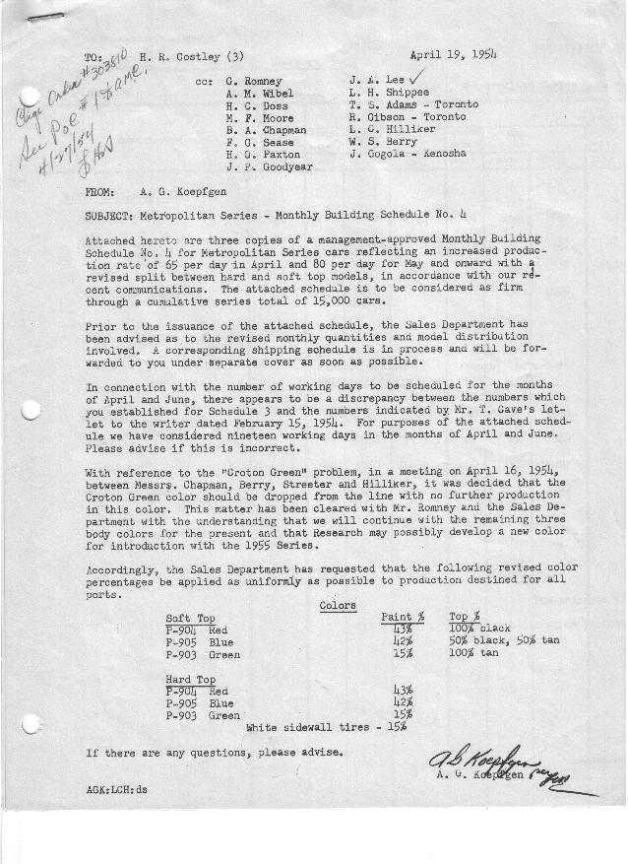

FORM PLAN 68 REV. 9-40-N.K.P PRINTED IN U.S.A

SCHEDULE NO. ______4_________ DATE April 13, 1954 MONTHLY BUILDING SCHEDULE APPROVED_____F. G. Sease (signed) ________DATE__4-19-54 ___ REVISION NO. ________________ DATE ________________ PRODUCT APPROVED_____B. A. Chapman (signed) ___________DATE__4-20-54____ ___
Metropolitan Series – Austin Motors Co., Ltd., - England
DESCRIPTION | BUILT  ACT◻ EST  THRU  3-31-54 | FIRM BUILDING SCHEDULE (a)  (FABRICATED MATERIAL RELEASE) |  |  |  |  |  |  |  |  |  |  |  |  |  |  |  |  |  | GRAND  TOTAL
DESCRIPTION | BUILT  ACT◻ EST  THRU  3-31-54 | MONTH April  DAYS 19 |  |  | MONTH May  DAYS 21 |  |  | MONTH June  DAYS 19 |  |  | MONTH July  DAYS 17 (b) |  |  | MONTH August  DAYS 16 (b) |  |  | MONTH September  DAYS 22 |  |  | GRAND  TOTAL
DESCRIPTION | BUILT  ACT◻ EST  THRU  3-31-54 | DAILY | MONTH | CUM’L  TOTAL | DAILY | MONTH | CUM’L  TOTAL | DAILY | MONTH | CUM’L  TOTAL | DAILY | MONTH | CUM’L  TOTAL | DAILY | MONTH | CUM’L  TOTAL | MONTH | MONTH | MONTH | GRAND  TOTAL
METROPOLITAN SERIES
Hard-Top Conv. | 1954 | 32.5 | 620 | 2574 | 46 | 968 | 3542 | 48 | 912 | 4454 | 48 | 816 | 5270 | 60 | 960 | 6230 | 60 | 1320 | 7550
Soft-Top Conv. | 2105 | 32.5 | 620 | 2725 | 34 | 712 | 3437 | 32 | 608 | 4045 | 32 | 544 | 4589 | 20 | 320 | 4909 | 20 | 440 | 5349
Total | 4059 | 65 | 1240 | 5299 | 80 | 1680 | 6979 | 80 | 1520 | 8499 | 80 | 1360 | 9859 | 80 | 1280 | 11139 | 80 | 1760 | 12899
Over/(Under) Sched. #3 | 85 |  | 290 | 375 |  | 630 | 1005 |  | 570 | 1575 |  | 510 | 2085 |  | 480 | 2565 |  | 660 | 3225
 |  | MONTH October  DAYS 22 |  |  | MONTH November  DAYS 5
Hard-Top Conv. |  | 60 | 1320 | 8870 | 60 | 250 | 9120
Soft-Top Conv. |  | 20 | 440 | 5789 | 20 | 91 | 5880
Total |  | 80 | 1760 | 14659 | 80 | 341 | 15000
Over/(Under) Sched. #3 |  |  | 1434 | 4659 |  | 341 | 5000
NOTES
- Firm Schedule through 15,000 jobs
- Vacation period – July 26 – August 6 inclusive

